Report

# Samima Muhib, Group 2405

**Introduction**  
This project represents my initial attempt at creating a webpage using HTML for the Information Technology course. The main objective was to design a basic personal website that includes various sections, such as About Me, Hobbies, Favorite Websites, Weekly Schedule, Page Layout, and a Contact Form.

# 2. Project Tasks and Screenshots

# Part: Title and Meta Information

page title, author, and description.

Input

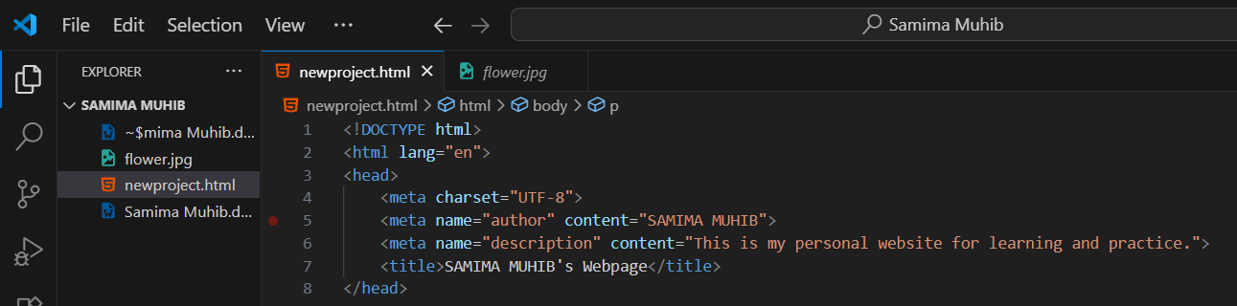  
output

# Part: About Me Section

personal information with heading and paragraph.

Input

output

## Part: My Hobbies

list of hobbies using <ul> tags.

input

output

## Part: Favorite Websites

favorite websites using <ol> and <a> tags.

input

output

## Part: My Photo

image with img tag.

Input

Output

## Part: Button with Alert

button that shows an alert when clicked.

input

output

## Part: Weekly Class Schedule

table for class schedule.

input

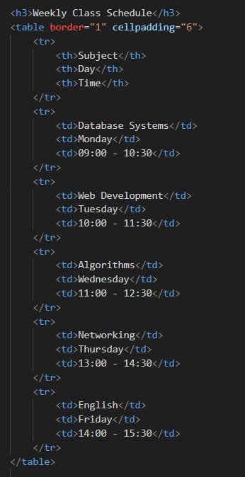

Output

## Part: Two-Column Layout

a simple layout using an HTML table with menu and main content.

Input

output

## Part: My Mood Today

text and emojis to show mood.

input

output

## Part: Contact Me Form

a form with input fields (name, email, favorite color).

input

Output

# 3. Work Process Summary

* I began by setting up the basic HTML framework using <!DOCTYPE html>, <html>, <head>, and <body>.
* Metadata and a suitable page title were then included.
* Next, I gradually built the sections: About Me, Hobbies, Favorite Websites, and Photo.
* I applied lists (ul, ol), hyperlinks (a), and images (img) where necessary.
* An interactive button was added with the onclick attribute.
* A weekly class schedule was organized using a table.
* For the layout, I designed a two-column structure consisting of a Menu and Main Content.
* To make the “Mood” section more engaging, I used emojis.
* At the end, I created a Contact Form with text, email, and color input options.
* After checking the project in the Chrome browser, everything functioned correctly without errors.

# 4. Conclusion

This project allowed me to strengthen my understanding of HTML basics, including the use of headings, paragraphs, lists, tables, forms, images, and links. I also gained experience in organizing a webpage effectively and adding interactivity through a button.

All sections were completed successfully, and the webpage runs smoothly in the browser without any issues.